Cmc lab1 documentation
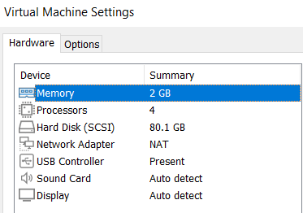
1 Vms vs containers
This is vm that carries docker and project when created it needed 2 GB of memory
While empty container in docker needed 41b
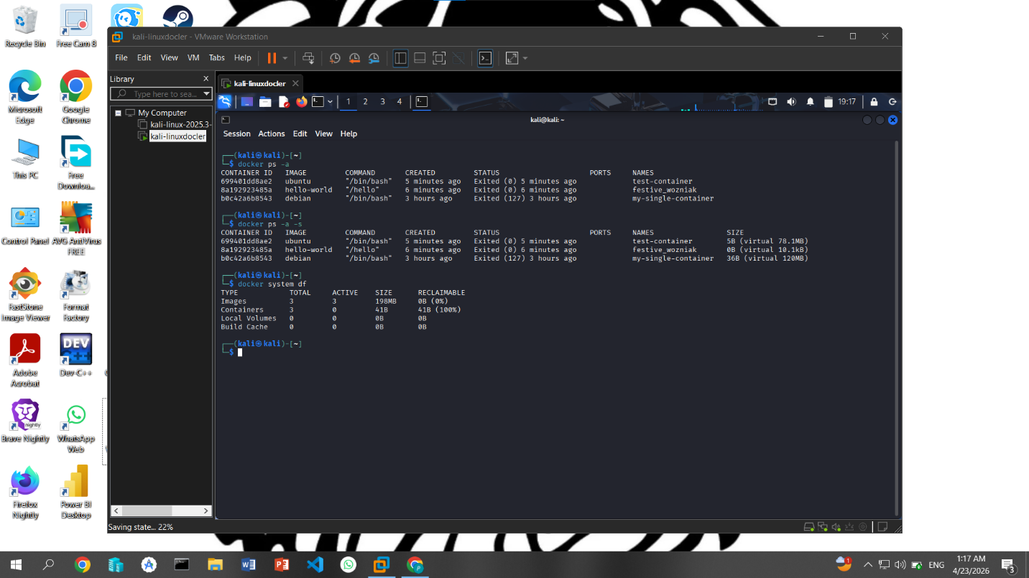
Proving containers take less resources than vm

2 cloud infrastructure
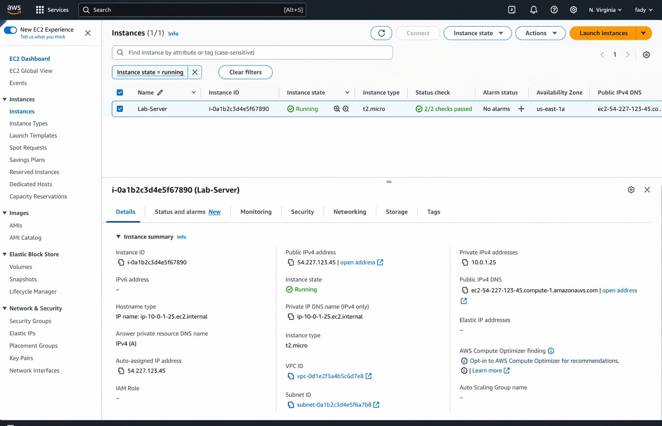

3tail latency
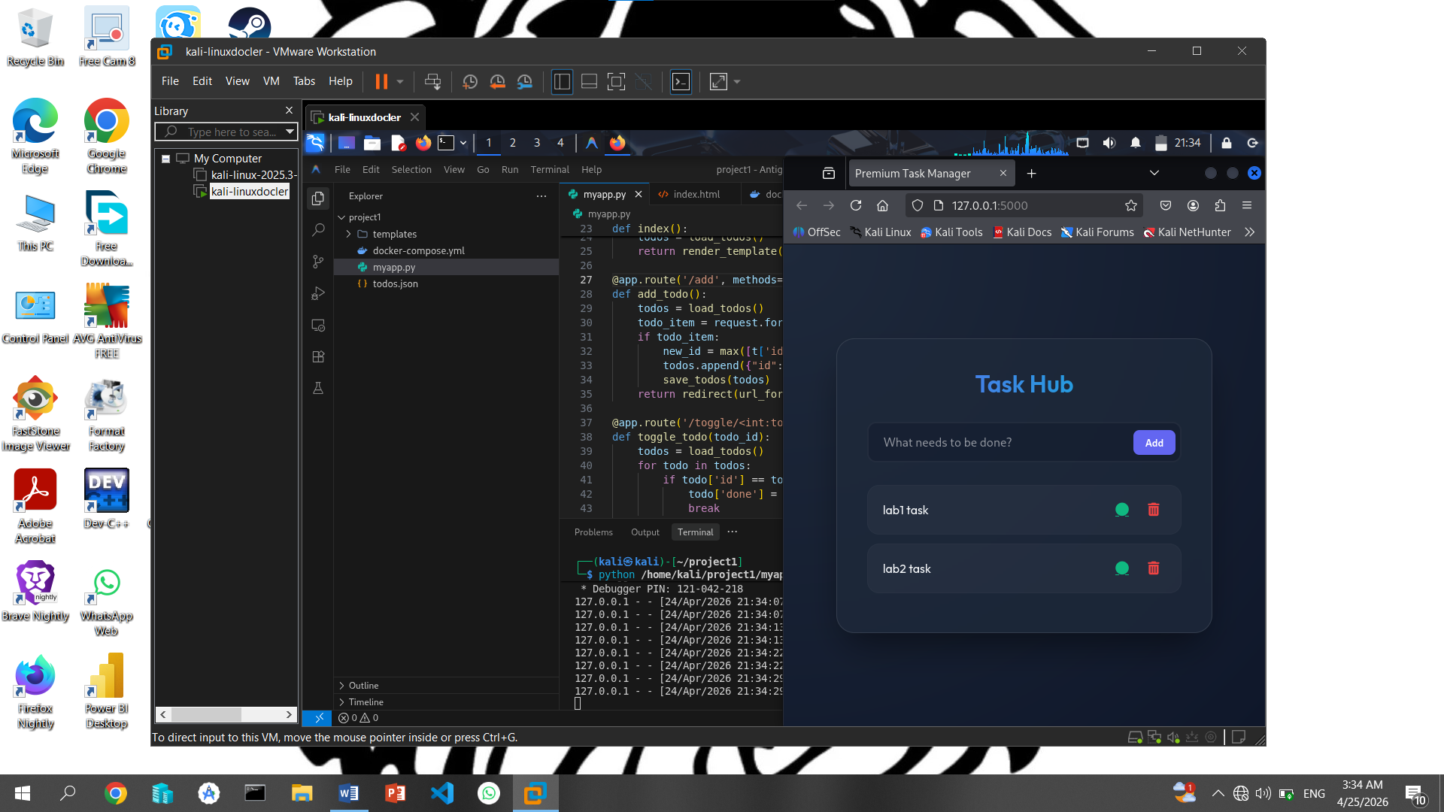
Deploy to do list flask app
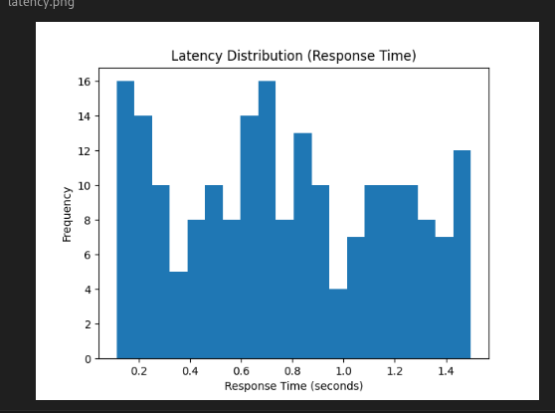
And this is latency diagram

